Firewall:

It is a network security system that monitors and controls incoming and outgoing network traffic based on predetermined security rules.
A firewall typically establishes a barrier between a trusted internal network and untrusted external network, such as the Internet.
It is a software or firmware that enforces a set of rules about what data packets will be allowed to enter or leave a network.
There are two main types of firewall:
1. Host based firewall
2. Network based firewall

Types of Firewalls:

1) Proxy Firewall
2) Stateful Inspection Firewall
3) Unified Threat Management (UTM) Firewall
4) Next-Generation Firewall (NGF)
5) Threat Focused Next-Generation Firewall

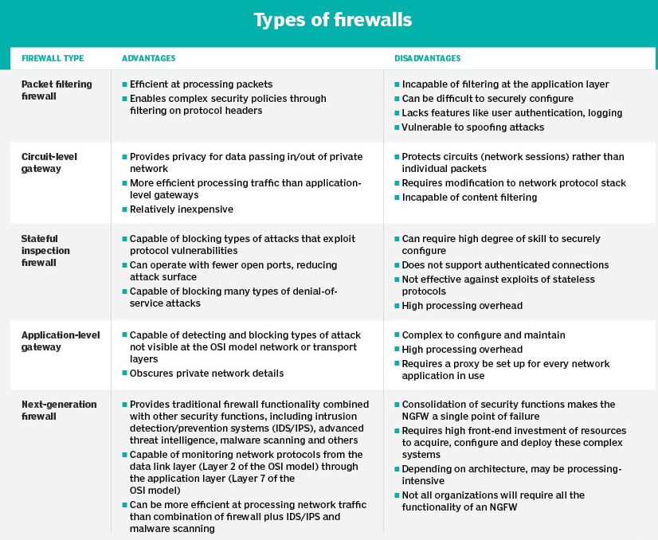

IP Tables:

- https://www.linode.com/docs/security/firewalls/control-network-traffic-with-iptables/
- https://www.youtube.com/watch?v=eC8scXX1_1M

